Experiences and lessons managing water in Cape Town with the advent of ‘Day Zero’
Robbie Parks, Megan McLaren, Ralf Toumi, Ulrike Rivett

Outline
- Introduction (IMPERIAL)
- ‘Water is a natural resource that is embedded in the cultural and religious values of societies. It is what we take pictures or create paintings of. It is why we construct fountains.’¹
- Hydrological drought is associated with precipitation shortage on a longer time scale (12 months to 2 years or more).
  - The challenge of water management and drought globally
    - Importance of good water management
- Demand for water is growing, both due to population increases, changing diets, as well as changes in the way people aspire to use water.
- ‘There are many regions where our freshwater resources are inadequate to meet domestic, economic development and environmental needs’¹
- ‘In recent decades the percentage increase in water use on a global scale has exceeded twice that of population growth’¹
- ‘1 of every 6 units of water treated across the United States never reaches the consumer.’²
    - Globalization of water
    - Changing supply and demand patterns due to climate change
    - Growing urban demand
- ‘Urban water demand will increase by 80% by 2050, while climate change will alter the timing and distribution of water’.³
- More than 27% of cities studied, containing 233 million people, will have water demands that exceed surface-water availability³
    - Freshwater stress
    - Monitoring use/new technologies
  - Overview of Cape Town and South Africa
- High drought frequency but relatively low intensity.⁴
- ‘Drought is a regular feature of the South African climate’.⁵
- Studies of the normalised vegetation index dataset (Los et al., 1994) show that the impact of droughts on vegetation (Farrar et al., 1994) is particularly strong where annual rainfall amount varies from 300 to 500 mm (Richard and Poccard, 1998). This is the case for most of South Africa.⁵
- Fig:2 Global urban water security (n=482).³
  - Usefulness of Cape Town as an example of an industrialised city in a semi-developing country (i.e. many examples relevant to many places in world)
  - Water guarantee in the South African constitution
- ‘Section 27: the rights to food, water, health care and social assistance, which the state must progressively realise within the limits of its resources’.
  - Main supplies and uses of water in Africa and Cape Town
    - Overview of surface water
    - Rain
- Strong inter-annual variability rainfall variability since 1970.⁵
- Average rainfall?⁵
    - Uses of water
- https://businesstech.co.za/news/general/104441/who-is-using-all-the-water-in-south-africa/

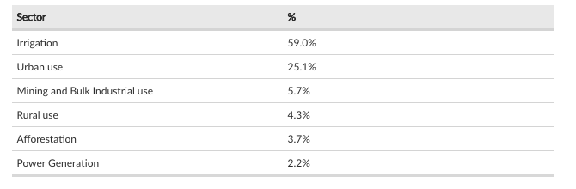

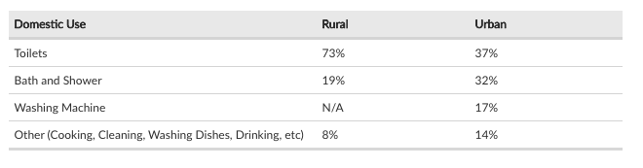

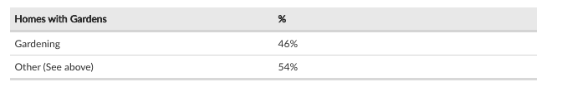

- Why is Cape Town experiencing drought? (IMPERIAL)
  - What is ‘Day Zero’?
  - Weather and climate context
  - Overview of Cape Town’s seasonal water cycle and supply
  - Threats to water supply under climate change

- How is drought impacting Cape Town? (IMPERIAL/UCT)
  - Management and rationing of water
  - Social and behavioural impacts
  - Health impacts
  - Economic impacts
  - Differential of impacts on different strata of society (rich/poor/black/white)

- How is Cape Town adapting to its new reality? (UCT)
  - Early Warning Systems of drought
  - Water proliferation technology, what works and what doesn’t
  - Monitoring water use
  - Increasing transparency of existing water usage data

- Policy recommendations (IMPERIAL/UCT)
  - Lessons learnt
  - What works and what doesn’t
  - Technological recommendations
  - Social policy recommendations
  - How to engender long-lasting behavioural change
  - Relevance to other places in the world

Bibliography
1 Cosgrove WJ, Loucks DP. Water management: Current and future challenges and research directions. Water Resour. Res. 2015; 51: 4823–39.
2 Chini CM, Stillwell AS. The State of U.S. Urban Water: Data and the Energy-Water Nexus. Water Resour. Res. 2018. DOI:10.1002/2017WR022265.
3 Flörke M, Schneider C, McDonald RI. Water competition between cities and agriculture driven by climate change and urban growth. Nat Sustain 2018; 1: 51–8.
4 Spinoni J, Naumann G, Carrao H, Barbosa P, Vogt J. World drought frequency, duration, and severity for 1951-2010. Int J Climatol 2014; 34: 2792–804.
5 Rouault M, Richard Y. Intensity and spatial extension of drought in South Africa at different time scales. Water SA 2003; 29: 489–500.

